**Brook – problem statement says introduction and data description come before analysis 1.**

**Introduction:**

Real estate company Century 21 Ames, selling homes in Ames, Iowa has come to us with a data set and some questions pertinent to their business. In this paper, we will address Century 21 Ames’ specific questions in our first analysis, before proceeding with a second analysis exploring the data on our own to predict sales prices of houses in all of Ames Iowa.

**Data Description**:

The [Ames Housing dataset](http://www.amstat.org/publications/jse/v19n3/decock.pdf) was compiled by Dean De Cock for use in data science education. We have used this dataset throughout our analysis, it is contained in the files “train.csv” and   
“test.csv.” This dataset gives the sale price of homes in all of Ames, Iowa from 2006 to 2010. The dataset also provides 79 variables that were identified as possible explanatory variables for assessing the sale price of a home in Ames. There are 2921 observations in the dataset, and they have been split almost evenly between our model training csv file and model testing csv file.

Further information about the data can be found at <http://jse.amstat.org/v19n3/decock.pdf>

Our model for Century 21 Ames’ problem aims to predict the variable “SalePrice.” Our client has specifically asked us to only focus on the relationship of the explanatory variables referring to square footage of the living area of the house and the neighborhood the house is set in. These variables are labeled as “GrLivArea” and “Neighborhood” respectively.

* Here we will address the variables we end up using for analysis 2

**ANALYSIS 1:**

**Restatement of Problem:**

Our client, Century 21 Ames, sells houses in three neighborhoods of Ames, Iowa. These neighborhoods are Brookside, Edwards and N. Ames. Century 21 Ames would like us to estimate how the sale price of a house in one of their neighborhoods is related to the square footage of the living area of the house. They would also like to know if the sale price and aforementioned relationship with the living area depend on the neighborhood the house is being sold in.

**Build and Fit of the Model:**

Build and fit a model that will answer this question, keeping in mind that realtors prefer to talk about living area in increments of 100 sq. ft. Provide your client with the estimate (or estimates if it varies by neighborhood) as well as confidence intervals for any estimate(s) you provide. – We can delete this after we’re done, good to have as a reference until finished

**Model fitting**

fit diagnostics for different cases

Linear – linear model

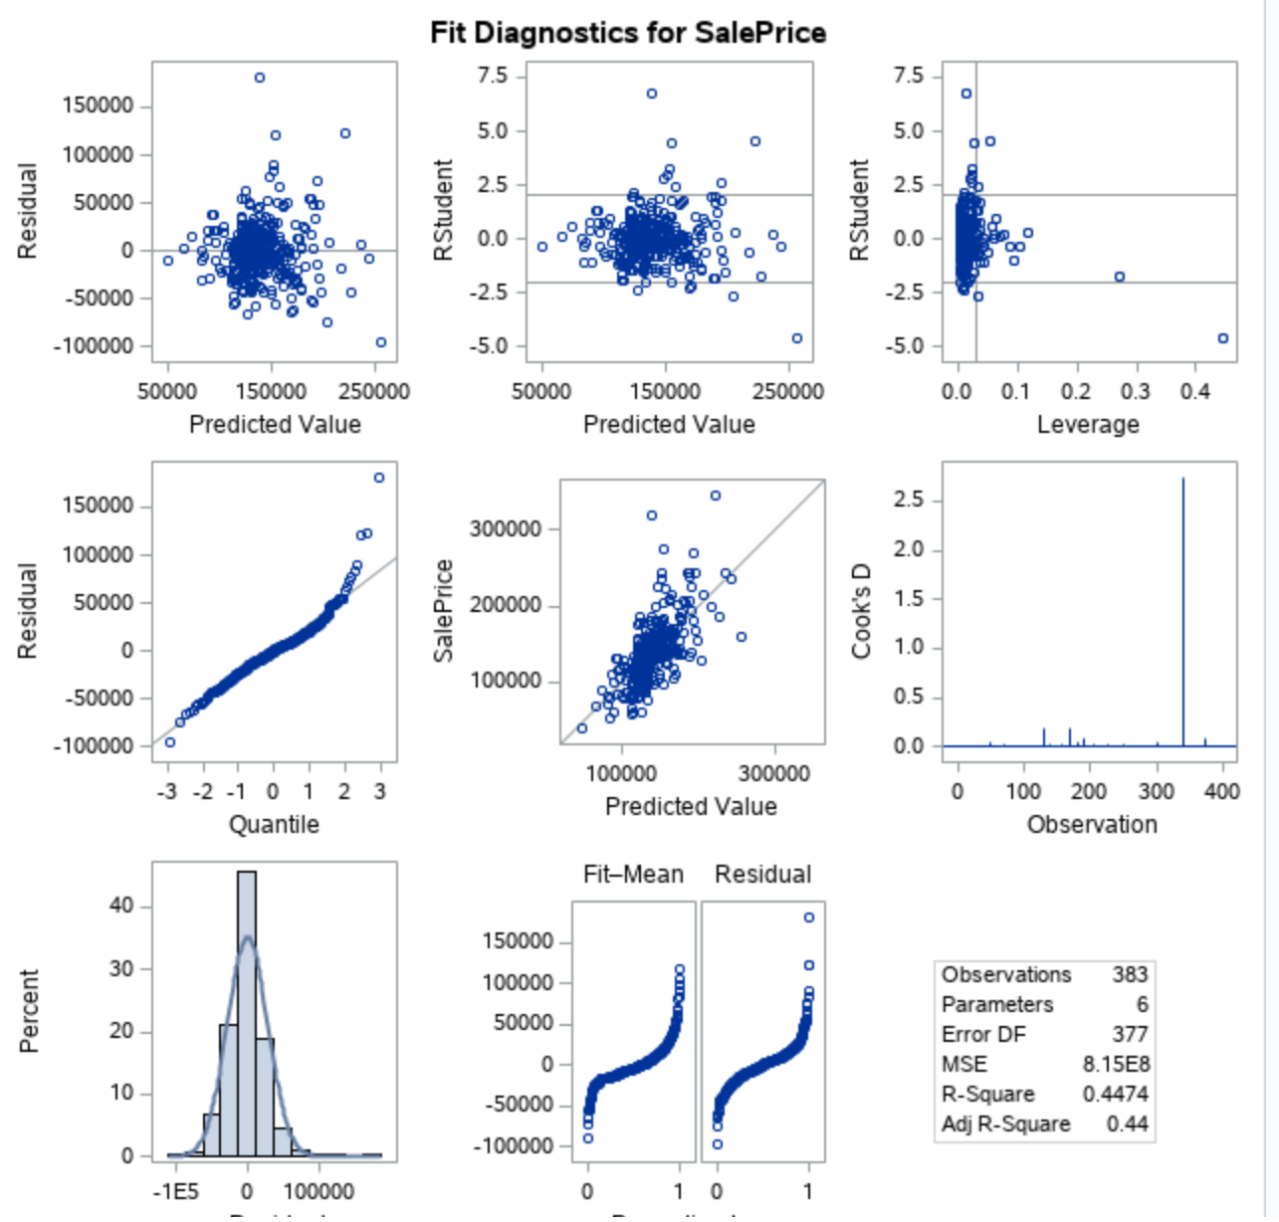

**The residual plot also presented as**

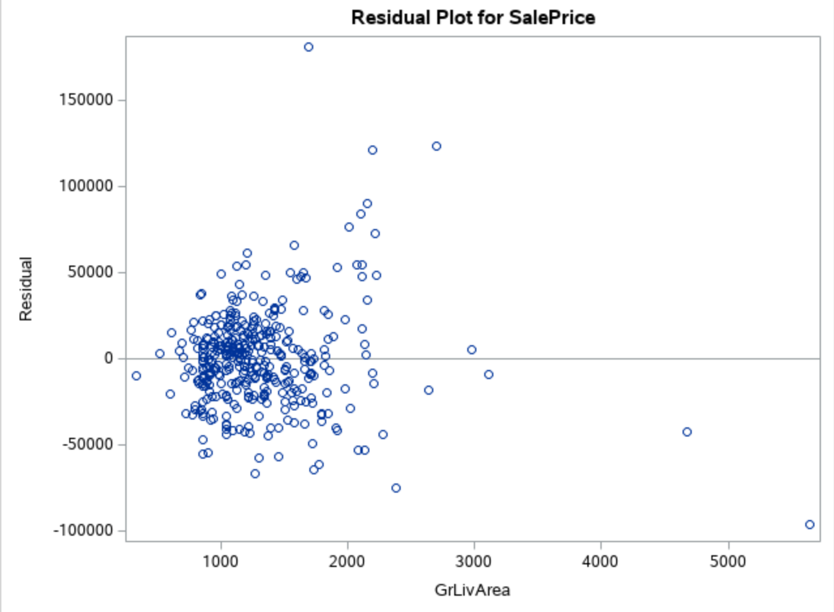

**Comparing Competing Models:**

Adj R2

Internal CV Press

Brook – I’ve removed the linear-log section, I don’t think there’s a need to include it if it is not going to be used, unused EDA doesn’t have to be presented

**Log log model**

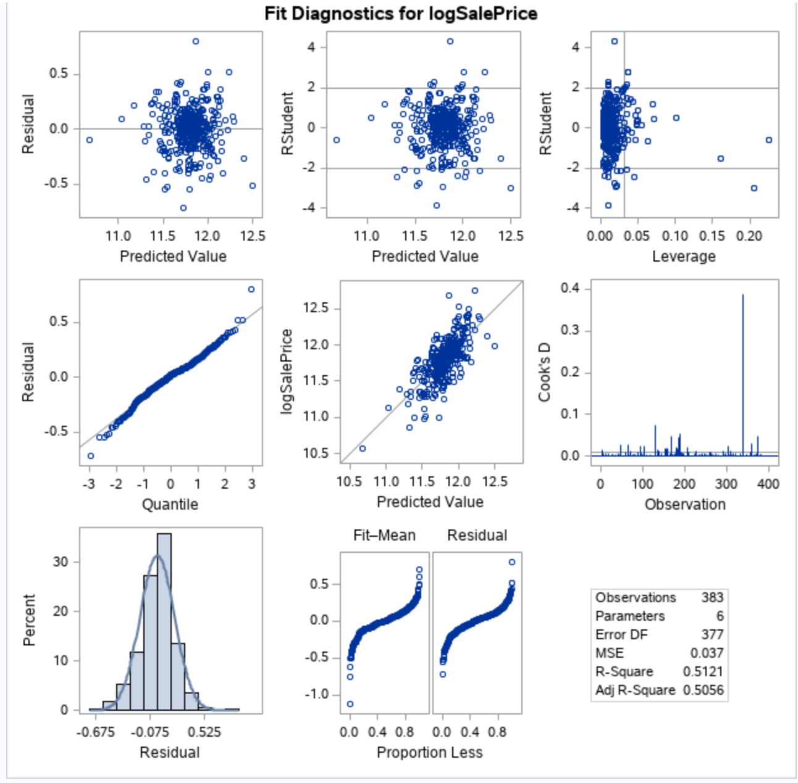

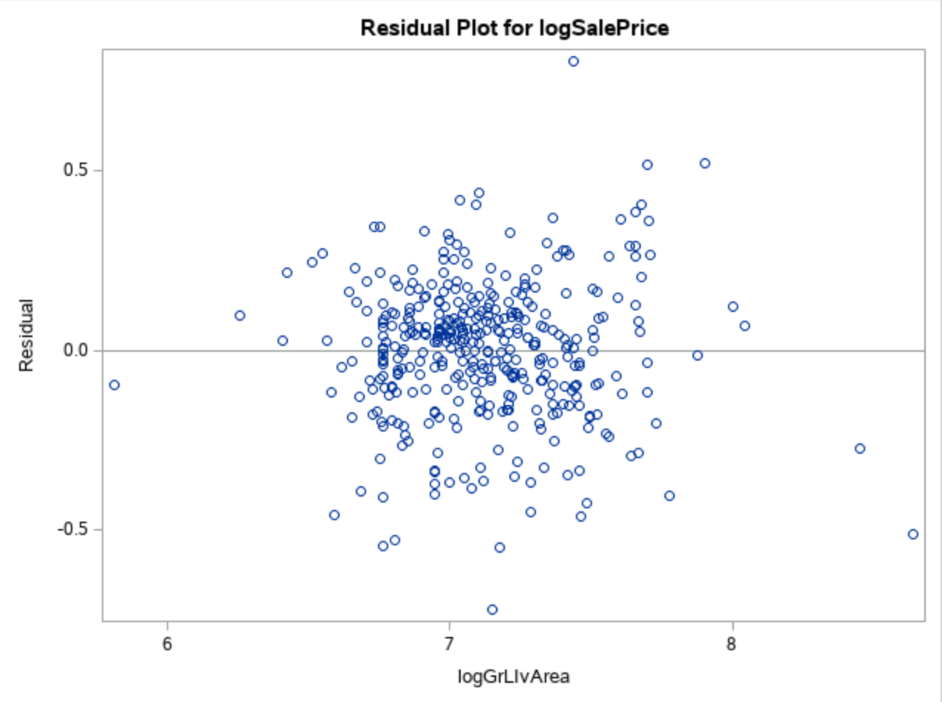

**Checking Assumptions:**

* Residual Plot: The residual plot resembles somewhat of a random scatter of points around the 0 line, although there is a slight suspicion of non-constant variance judging from the dense cloud around.
* Studentized Residual Plot: This plot is very similar to the residual plot, although this plot identifies potential outlying observations. This plot identifies a potentially very outlying point with a predicted value of 15. This may provide some evidence against the normality assumption and this point should be examined further.
* Histogram of Residuals: The histogram of residuals displayed does not provide strong evidence that the residuals are not normally distributed.
* Q-Q Plot of Residuals: The Q-Q Plot of residuals provides no evidence against the residuals being normally distributed.
* The model is a reasonable fit with transformations, although transformations may be investigated to handle the possible problem with equal standard deviations.

**A discussion supporting the use of the model you chose (support that the assumptions are met).**

* Linearity: Met with original and log-log model. (view scatterplots)
* Normality: Log-log model looks slightly better. (view histograms)
* Equal standard deviations: Log-log model looks much better. (view residual scatter plots)
* Independence: We will assume independence, although not much is known about how these species were chosen.
* Outliers: There are some outliers at the tail end of the data set but the log log model looks better.
* We will proceed to make inferences on a log – log model.

Residual Plots

Influential point analysis (Cook’s D and Leverage)

Observed significant Cook’s D observation on all models except the linear model which only has one spike at the tail end of the observations

Leverage seems normal for all the three models

**Parameters:**

Estimates

From the log – log model ;

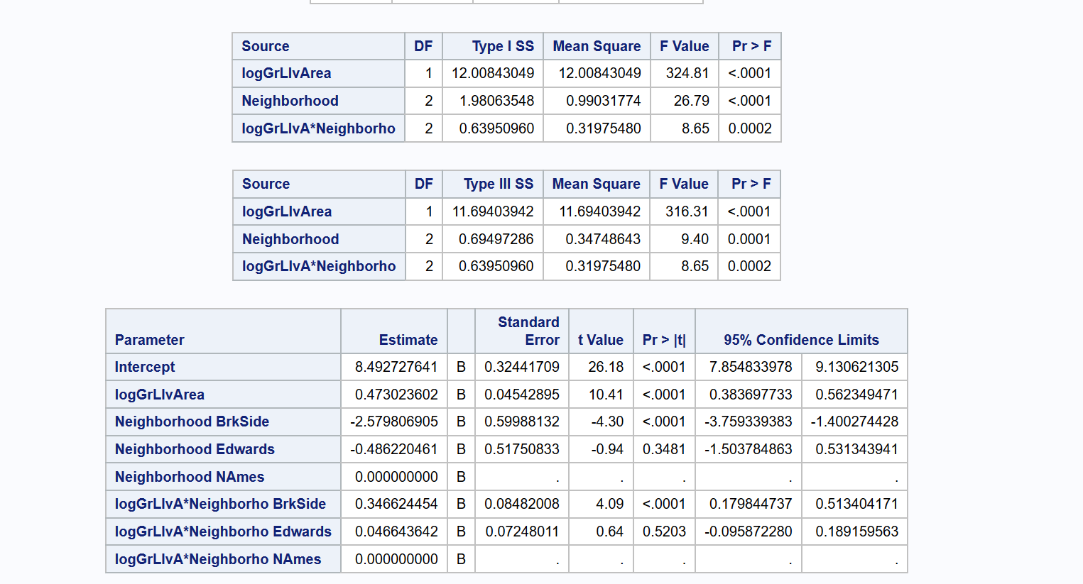

Interpretation

Confidence Intervals

**Conclusion:**

A short summary of the analysis.

Brook – I have uploaded my code below yours, I think mine is a little more clear.. what do you think John?

Analysis Question 2

Restatement of Problem

Build the most predictive model for sales prices of homes in all of Ames Iowa. This includes all neighborhoods.

Model Selection

Type of Selection

Forward

Forward Model Analysis

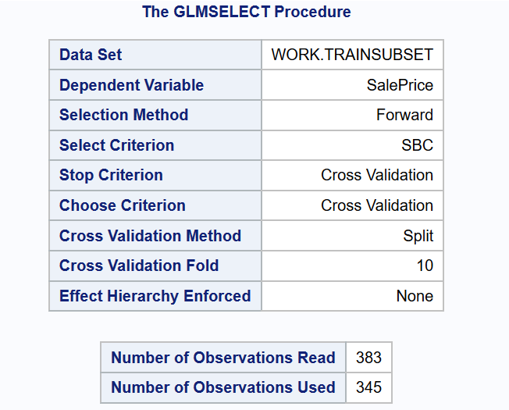

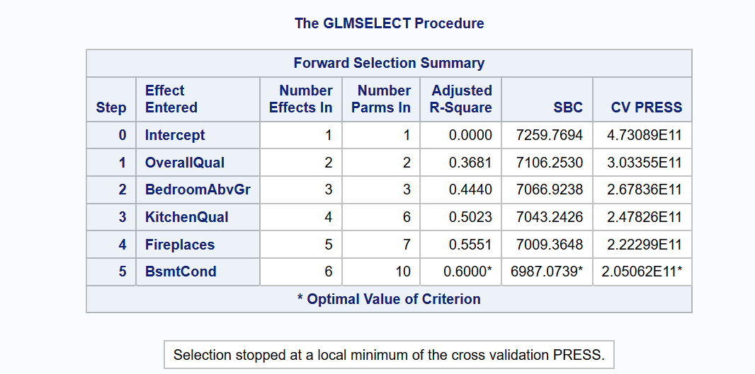

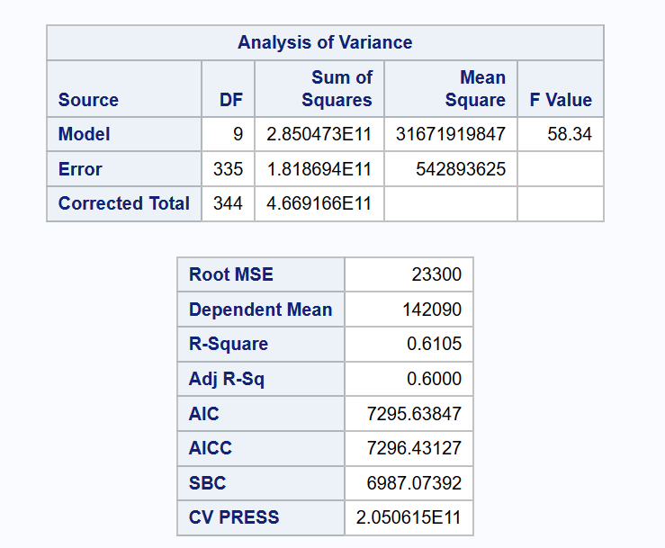

F stat looks small even though p value is not given and it is good to have small p value.Use this to calculate P value of F stat given both numerator and denominator df

<https://www.danielsoper.com/statcalc/calculator.aspx?id=7>

The minimum CV press value for the forward selection is given

Dependent mean is the mean of the response variable ( Sale Price mean)

Finally After we evaluate all the parameters of the proc glmselect out put we found that the candidate predictors with regression parameters are These , but am not okay with negative value for positive actual dimension , so I will change the variable selection model

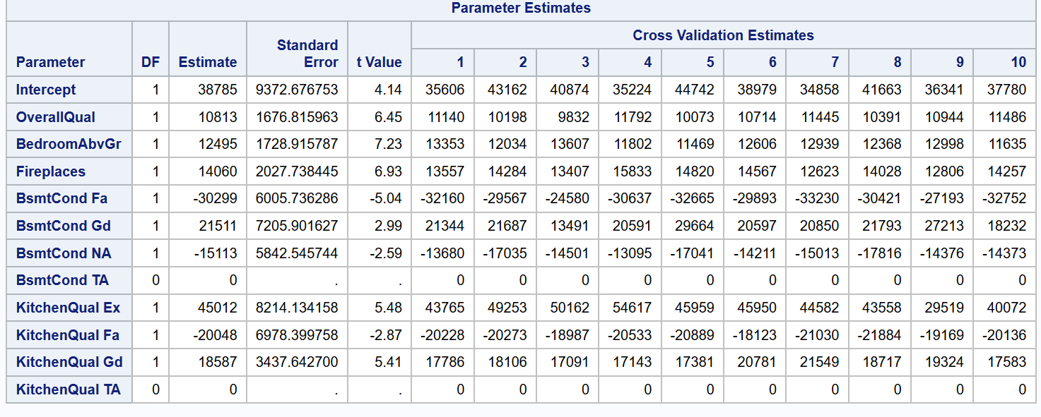

Backward

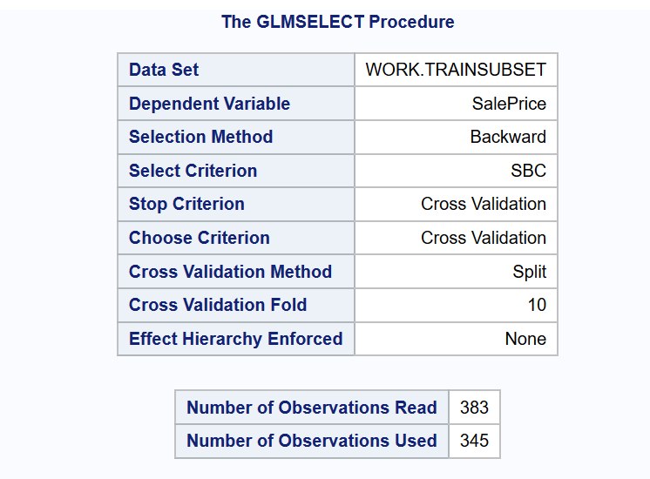

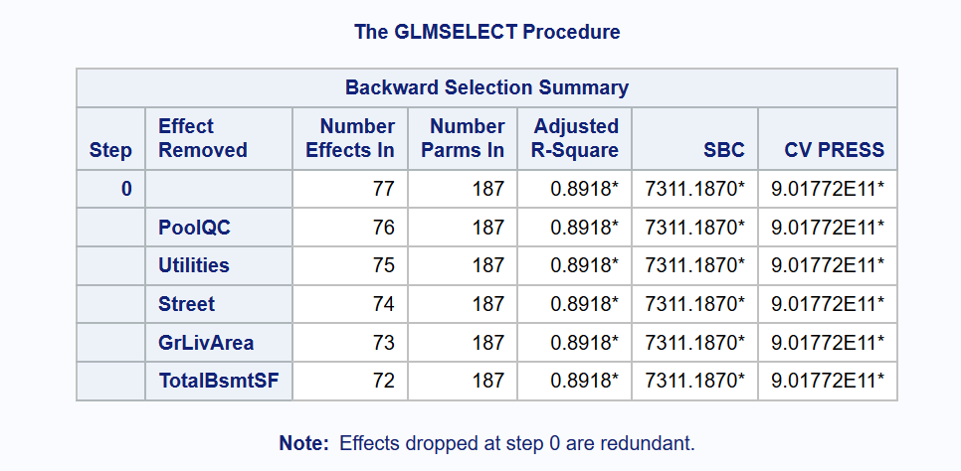

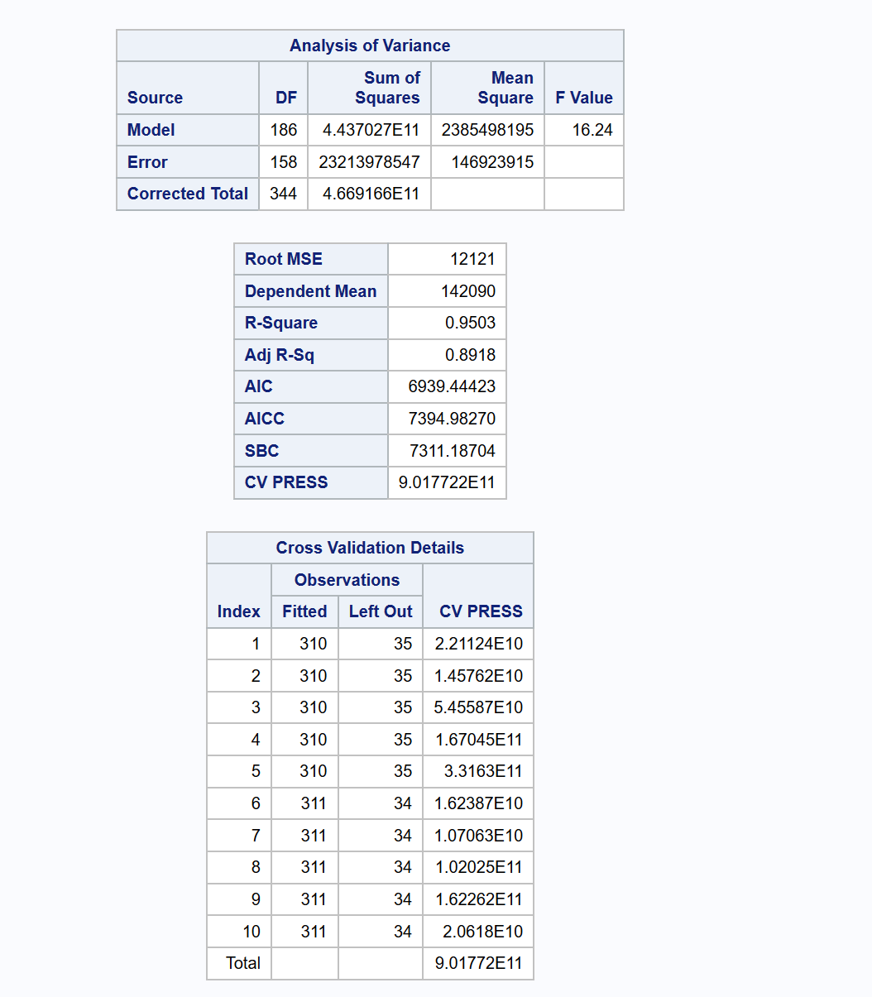

The back ward model selection didn’t provide a good subset of candidate regressors , instead it created a lot of regressors , as a principle of parsimony , I would not approve a very complicated model that involves mutile varriables

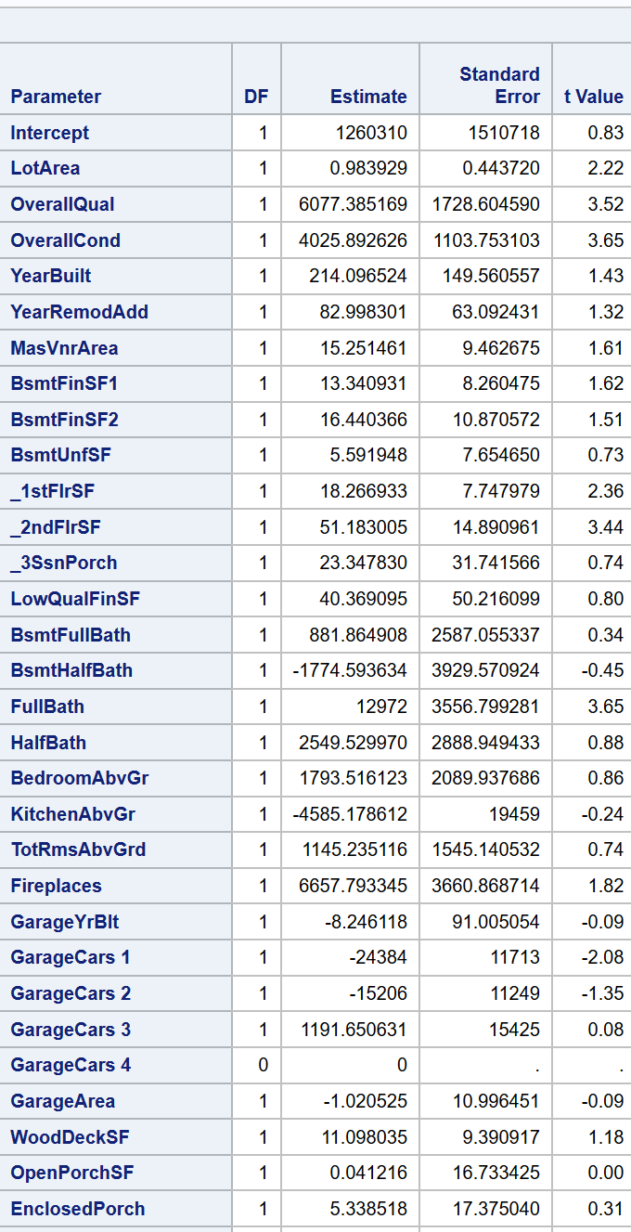

Stepwise

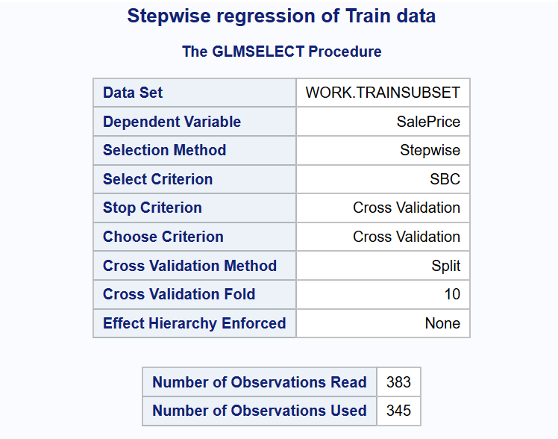

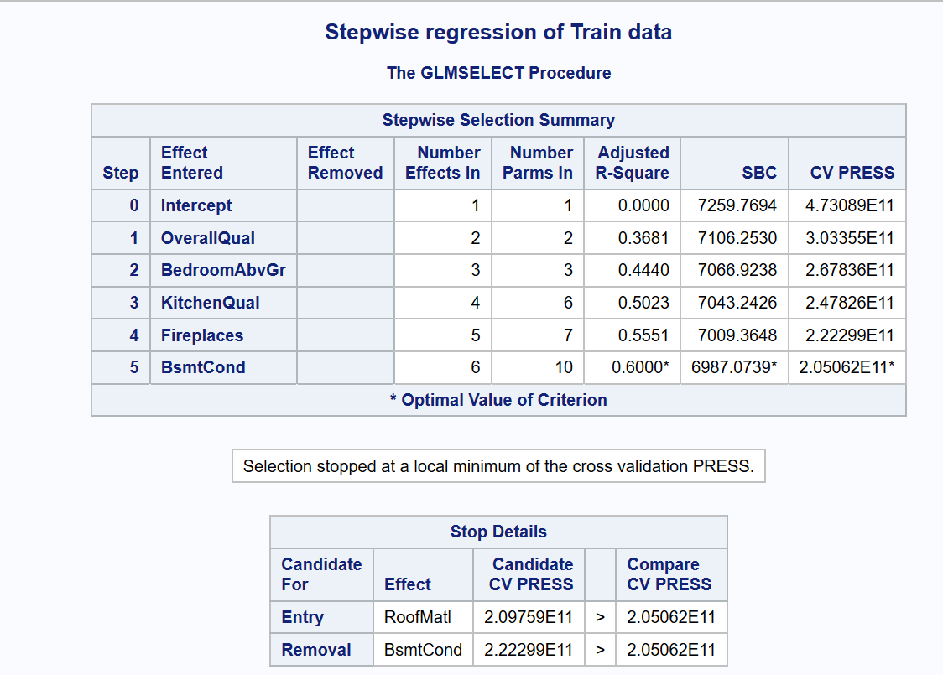

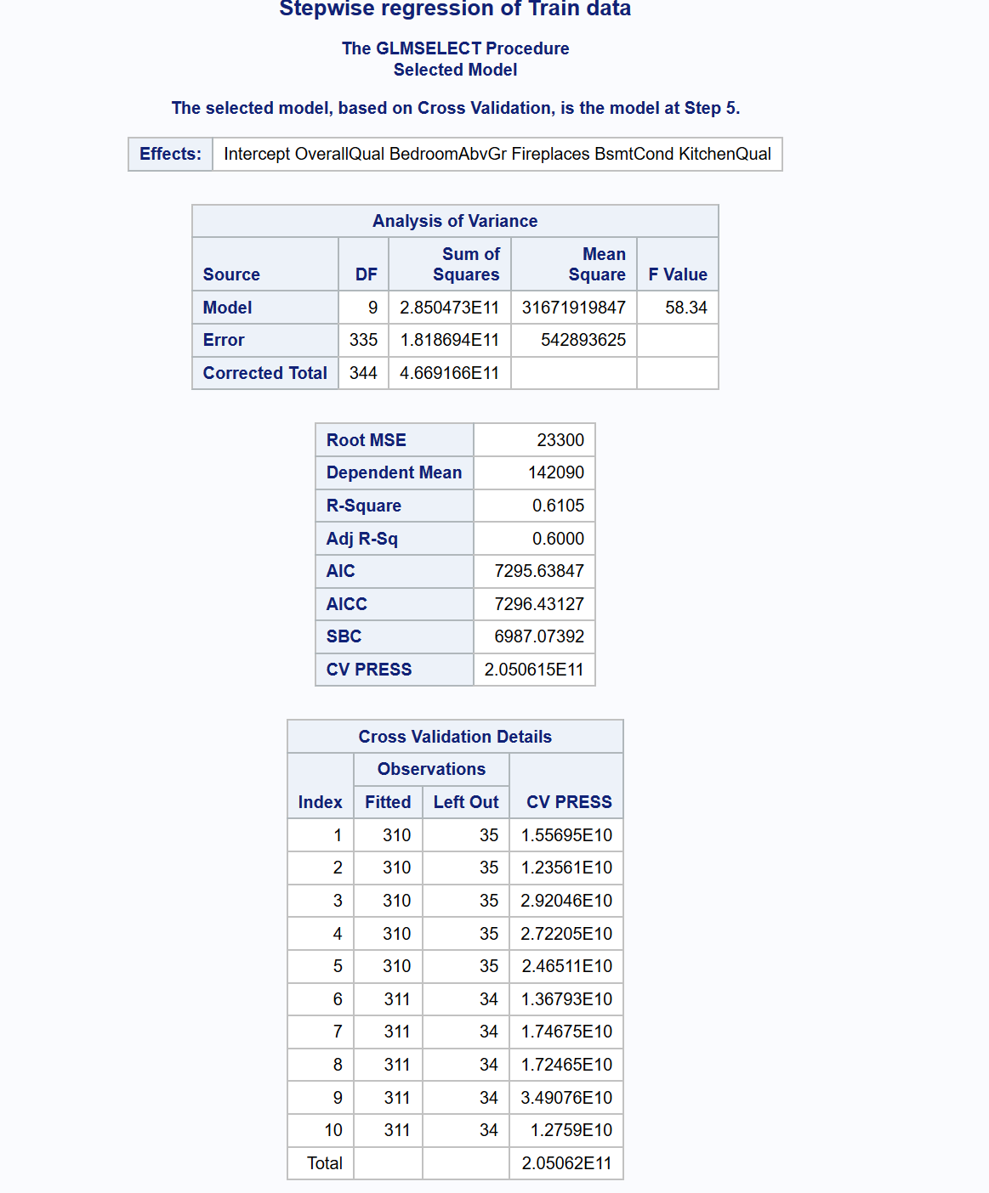

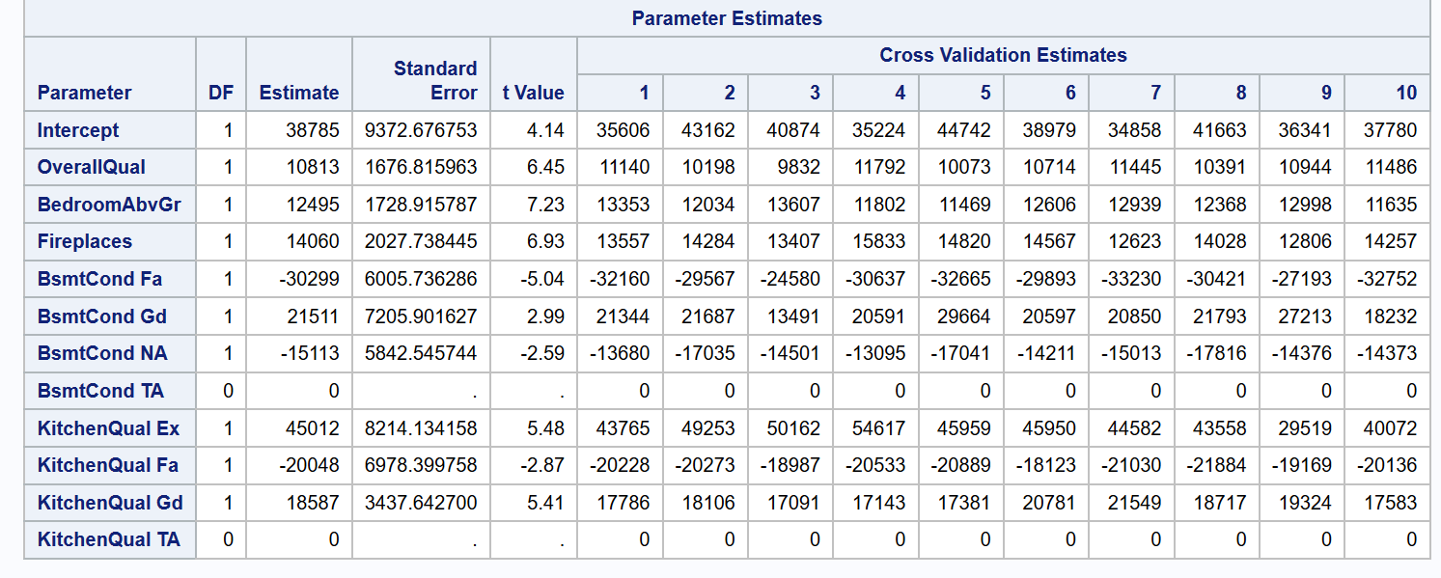

**Custom**

Based on the Stepwise model, I will select the candidate parameters that I think are reasonable predictors. The stepwise model has lower internal cv press though the adjusted R square is smaller than the Backward model. Adjusted R square is mostly a poor selection criterion as it can be artificially inflated by other factors. Only one model is selected, and even that is not guaranteed to be the “best”; there may be other, more parsimonious or more intuitively reasonable models that may provide nearly as good or even better models, but which the particular heuristic method employed does not find. I used CV as my selection criterion though there are multiple selection or choose criterion like *ADJRSQ ( SL ),* AIC , AICC , BIC ,SBC , CP, PRESS. Hence My custom model will be comprised of sales price as dependent variable and the following regressors as numeric and class varriables

overallQual , BedroomAbvGr, Fireplaces**, Neighborhood, BsmtCond , KitchenQual** as class varriables here I added Neighborhood and GrLivArea, as it is requested as QOI in the problem statement but its not chosen as a regressor candidate in my model selection **.**

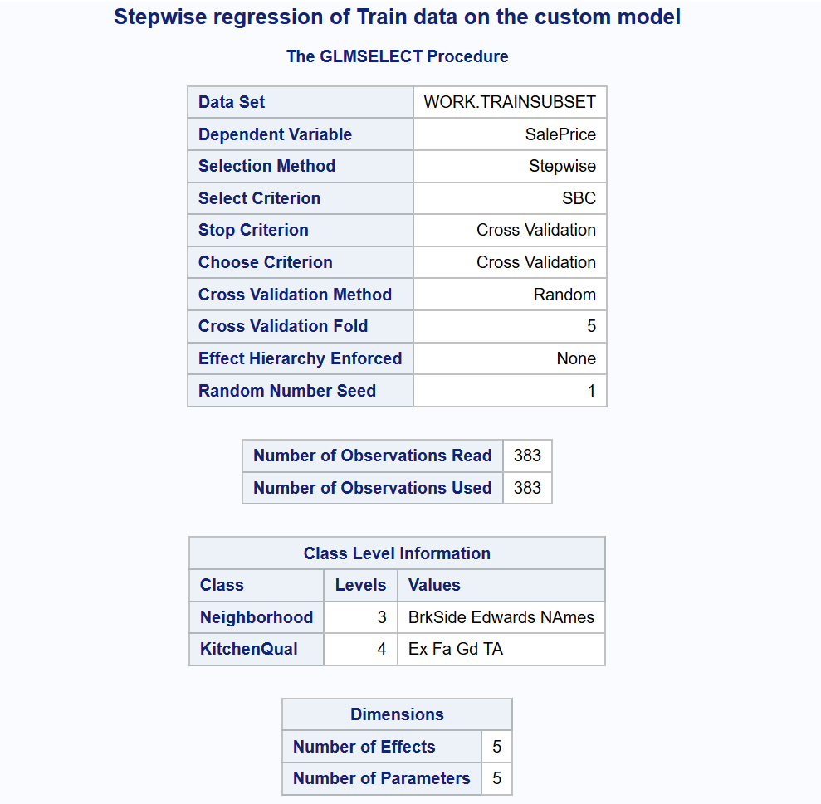

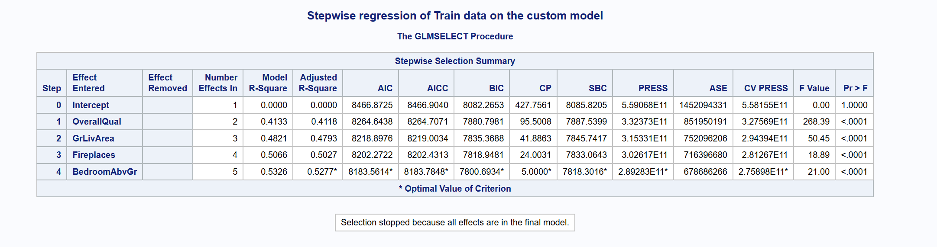

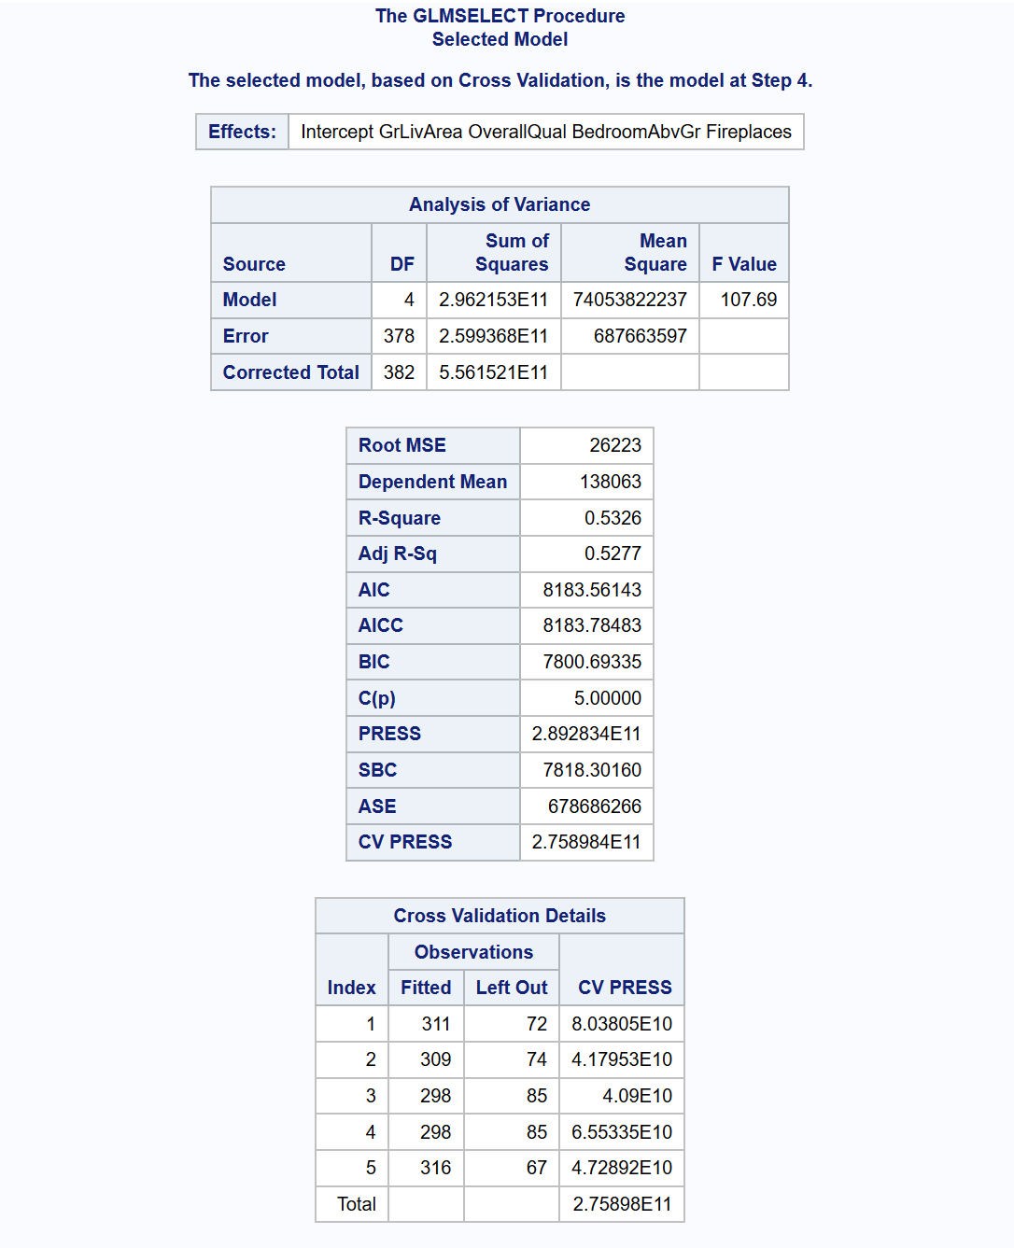

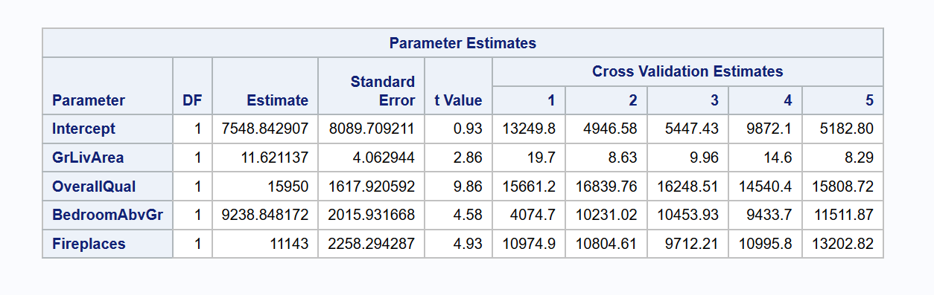

**QOIs:** [**https://www.youtube.com/watch?v=0QJtczDPxZQ**](https://www.youtube.com/watch?v=0QJtczDPxZQ)

|  |  |  |  |
| --- | --- | --- | --- |
| **Predictive Models** | **Adjusted R2** | **CV PRESS** | **Kaggle Score** |
| Forward | .60 | 2.050611E11 |  |
| Backward | .89 | 9.017722E11 |  |
| Stepwise | .60 | 2.056011E11 |  |
| CUSTOM | .52 | 2.75898E11 |  |

Checking Assumptions

Residual Plots

Influential point analysis (Cook’s D and Leverage)

Make sure to address each assumption

Comparing Competing Models

Adj R2

Internal CV Press ????????? how are we generate CV press for our final model

Unles we use glmselect

Kaggle Score

Conclusion: A short summary of the analysis.

Appendix

Well commented SAS Code for Analysis 1 and 2

**Rubric:**

Presentation (30%):

Organized paper with title, headings, subheadings, etc.

Labeled plots, figures, tables and charts.

Every plot, figure, table and chart included is referenced in the paper and vice versa.

No spelling or grammatical errors.

Analysis Question 1: (35%)

Analysis Question 2: (35 %)

**Appendix:**

**Code and additional screen shot of plots and graphs for analysis 1**

proc import datafile='/folders/myfolders/testCleaned.csv'

DBMS=csv out=work.testCleaned replace;

run;

proc print data=work.testCleaned;

run;

proc import datafile='/folders/myfolders/train.csv'

DBMS=csv out=work.train replace;

run;

proc print data=work.train;

run;

* Build a Model;

*

* Fit plot assesment on log log model ;

proc glm data = logtrain plot = all;

class neighborhood;

model SalePrice = GrLivArea |neighborhood / solution;

run;

*log - log model ;

proc glm data = logTrain plots = all alpha = 0.05;

class neighborhood;

model logSalePrice = logGrLivArea |neighborhood / solution clparm;

run;

* linear log model ;

proc glm data = logTrain plots = all alpha = 0.05;

class neighborhood;

model SalePrice = logGrLivArea |neighborhood / solution clparm;

run;

*log - linear model;

proc glm data = logTrain plots = all alpha = 0.05;

class neighborhood;

model logSalePrice = GrLivArea |neighborhood / solution clparm;

run;

proc reg data = logTrain ;

model logSalePrice = logGrLivArea /VIF ;

run;

*Coded scatter plot ;

proc sgplot data=train;

reg x=GrLivArea y=SalePrice / group=neighborhood clm cli;

proc sgplot data=train;

where neighborhood ne contains ('NAmes', 'Edwards' ,'BrkSide') ;

reg x=GrLivArea y=SalePrice / group=neighborhood clm cli;

# Create our data set to answer Century 21 Ames’ questions. Select only the neighborhoods they care about, and create log values for our numerical variables in case we determine a transformation is necessary. Also, sort by neighborhood for clarity when looking at the raw data:

data Century21;  
 set train;   
 if Neighborhood = 'BrkSide' OR Neighborhood ='NAmes' OR Neighborhood = 'Edwards';  
 logGrLivArea = log(GrLIvArea);  
 logSalePrice = log(SalePrice);  
 run;

proc sort data = Century21;

by Neighborhood;

run;

# Create our linear regression model for initial analysis:

proc glm data = Century21;

class Neighborhood;

model SalePrice = GrLivArea | Neighborhood;

run;

# Convert to a log-log model after checking assumption:

proc glm data = Century21;  
class Neighborhood;   
model logSalePrice = logGrLIvArea| Neighborhood / solution clparm;  
run;

**Code and additional screen shot of plots and graphs for analysis 1**

Forward model

proc glmselect data=TrainSubset

seed= 1 plots(stepAxis=number)=(criterionPanel ASEPlot CRITERIONPANEL);

class MSSubClass neighborhood MSZoning Street LotShape LandContour Utilities LotConfig LandSlope Condition1

Condition2 BldgType HouseStyle RoofStyle RoofMatl Exterior1st Exterior2nd MasVnrType ExterQual

ExterCond Foundation BsmtQual BsmtCond BsmtExposure BsmtFinType1 BsmtFinType2 Heating HeatingQC

CentralAir Electrical KitchenQual Functional FireplaceQu GarageType GarageFinish GarageCars

GarageQual GarageCond PavedDrive PoolQC Fence MiscFeature SaleType SaleCondition LotFrontage;

model

SalePrice = LotArea OverallQual OverallCond YearBuilt YearRemodAdd MasVnrArea

BsmtFinSF1 BsmtFinSF2 BsmtUnfSF TotalBsmtSF _1stFlrSF _2ndFlrSF _3SsnPorch LowQualFinSF GrLivArea

BsmtFullBath BsmtHalfBath FullBath HalfBath BedroomAbvGr KitchenabvGr TotRmsAbvGrd

Fireplaces GarageYrBlt GarageCars GarageArea WoodDeckSF OpenPorchSF EnclosedPorch

ScreenPorch PoolArea MiscVal MoSold YrSold

MSSubClass neighborhood MSZoning Street LotShape LandContour Utilities LotConfig LandSlope Condition1

Condition2 BldgType HouseStyle RoofStyle RoofMatl Exterior1st Exterior2nd MasVnrType ExterQual

ExterCond Foundation BsmtQual BsmtCond BsmtExposure BsmtFinType1 BsmtFinType2 Heating HeatingQC

CentralAir Electrical KitchenQual FireplaceQu GarageType GarageFinish GarageCars

GarageQual GarageCond PavedDrive PoolQC Fence MiscFeature SaleType SaleCondition

/selection=Forward(choose=cv stop=cv) cvmethod=split(10) stat=adjrsq cvdetails=all;

run;

**Backward model**

proc glmselect data=TrainSubset

seed= 1 plots(stepAxis=number)=(criterionPanel ASEPlot CRITERIONPANEL);

class MSSubClass neighborhood MSZoning Street LotShape LandContour Utilities LotConfig LandSlope Condition1

Condition2 BldgType HouseStyle RoofStyle RoofMatl Exterior1st Exterior2nd MasVnrType ExterQual

ExterCond Foundation BsmtQual BsmtCond BsmtExposure BsmtFinType1 BsmtFinType2 Heating HeatingQC

CentralAir Electrical KitchenQual Functional FireplaceQu GarageType GarageFinish GarageCars

GarageQual GarageCond PavedDrive PoolQC Fence MiscFeature SaleType SaleCondition LotFrontage;

model

SalePrice = LotArea OverallQual OverallCond YearBuilt YearRemodAdd MasVnrArea

BsmtFinSF1 BsmtFinSF2 BsmtUnfSF TotalBsmtSF _1stFlrSF _2ndFlrSF _3SsnPorch LowQualFinSF GrLivArea

BsmtFullBath BsmtHalfBath FullBath HalfBath BedroomAbvGr KitchenabvGr TotRmsAbvGrd

Fireplaces GarageYrBlt GarageCars GarageArea WoodDeckSF OpenPorchSF EnclosedPorch

ScreenPorch PoolArea MiscVal MoSold YrSold

MSSubClass neighborhood MSZoning Street LotShape LandContour Utilities LotConfig LandSlope Condition1

Condition2 BldgType HouseStyle RoofStyle RoofMatl Exterior1st Exterior2nd MasVnrType ExterQual

ExterCond Foundation BsmtQual BsmtCond BsmtExposure BsmtFinType1 BsmtFinType2 Heating HeatingQC

CentralAir Electrical KitchenQual FireplaceQu GarageType GarageFinish GarageCars

GarageQual GarageCond PavedDrive PoolQC Fence MiscFeature SaleType SaleCondition

/selection=Backward(choose=cv stop=cv) cvmethod=split(10) stat=adjrsq cvdetails=all;

run;

**Code for stepwise model selection**

proc glmselect data=TrainSubset

seed= 1 plots(stepAxis=number)=(criterionPanel ASEPlot CRITERIONPANEL);

class MSSubClass neighborhood MSZoning Street LotShape LandContour Utilities LotConfig LandSlope Condition1

Condition2 BldgType HouseStyle RoofStyle RoofMatl Exterior1st Exterior2nd MasVnrType ExterQual

ExterCond Foundation BsmtQual BsmtCond BsmtExposure BsmtFinType1 BsmtFinType2 Heating HeatingQC

CentralAir Electrical KitchenQual Functional FireplaceQu GarageType GarageFinish GarageCars

GarageQual GarageCond PavedDrive PoolQC Fence MiscFeature SaleType SaleCondition LotFrontage;

model

SalePrice = LotArea OverallQual OverallCond YearBuilt YearRemodAdd MasVnrArea

BsmtFinSF1 BsmtFinSF2 BsmtUnfSF TotalBsmtSF _1stFlrSF _2ndFlrSF _3SsnPorch LowQualFinSF GrLivArea

BsmtFullBath BsmtHalfBath FullBath HalfBath BedroomAbvGr KitchenabvGr TotRmsAbvGrd

Fireplaces GarageYrBlt GarageCars GarageArea WoodDeckSF OpenPorchSF EnclosedPorch

ScreenPorch PoolArea MiscVal MoSold YrSold

MSSubClass neighborhood MSZoning Street LotShape LandContour Utilities LotConfig LandSlope Condition1

Condition2 BldgType HouseStyle RoofStyle RoofMatl Exterior1st Exterior2nd MasVnrType ExterQual

ExterCond Foundation BsmtQual BsmtCond BsmtExposure BsmtFinType1 BsmtFinType2 Heating HeatingQC

CentralAir Electrical KitchenQual FireplaceQu GarageType GarageFinish GarageCars

GarageQual GarageCond PavedDrive PoolQC Fence MiscFeature SaleType SaleCondition

/selection=stepwise(choose=cv stop=cv) cvmethod=split(10) stat=adjrsq cvdetails=all;

Title 'Stepwise regression of Train data';

run;